M-BLANK Instruction Manual

Dr. Andrew M. Crawford, PhD

17 September 2020

Version: 1

Introduction
M-BLANK is a program for the processing and fitting of X-ray fluorescence datasets and is capable of handling photon data from a variety of sources. The data is initially converted to an M-BLANK common format. Subsequently, fitting parameters are developed for the dataset. If available mass standard scans were collected, a mass calibration can be calculated. Following this, the data can then be fitted and visualized to optimize the calculation of a blank and identify image regions of interest for analysis. As M-BLANK has developed, so too have different formats.

General

Available Downloads

Mac

Windows
Version 3:
2020.0829: https://drive.google.com/file/d/1RLubCw2eK_VKhMzYNSNbLCj6xwed2V0C/view?usp=sharing

Linux

Data Storage and Access:
M-BLANK stores data sparsely, this makes it highly compatible with the sparse nature of biological samples rapid scanned at synchrotrons. The most recent M-BLANK version (v3) deals with sparse storage of data.

Version 3:
This creates a main file (PATH\[filename].mblank) with sparse entries stored in a subdirectory of the same name as the filename (PATH\[filename]\):

SCALAR INFORMATION (2.1.1.1):
*.mblank: all scalars

SPARSE INFORMATION (2.1.1.2):
*.bin: uint16 - detector bin (sorted in ascending order)
*.nbin: uint32 - number of sparse entries for each bin
*.pix: uint32 - Pixel Number
*.det: uint16 - Detector Number
*.val: single - total detected counts for the entry (MAIA - all values are 1)
*.tim: single - peaking time (MAIA - used to calculate dead time)

Example:
PATH\FILE.mblank
PATH\FILE\sp.bin
PATH\FILE\sp.nbin
PATH\FILE\sp.pix
PATH\FILE\sp.det
PATH\FILE\sp.val
PATH\FILE\sp.tim

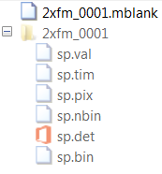

SCALAR INFORMATION (*.mblank) Binary Structure
# | Class | Size | Definition
1 | uint8 | 2 | First value is 0 and indicates “not legacy”; the second value indicates the file format version. e.g., 03 indicates version 3.
2 | uint16 | 1 | # of stored scalar values (N) (e.g., LTime, RTime, and ion chamber readings)
3 | uint16 | 1 | # of detector elements (D)
4 | uint16 | 1 | # of energy bins (B) in the xrf spectra
5 | uint64 | 1 | # of pixels (P)
6 | uint64 | 1 | # of x coordinates
7 | uint64 | 1 | # of x coordinates
8 | uint64 | 1 | # of stored sparse entries
9+ | 100Bytes | N | Names of the stored scalars: Each one will be stored using 100 bytes. The first byte will designate the length of the stored string in bytes and is encoded using uint8. Maximum length allowed is 99. The names should be alphanumeric + underscores and must be alphabetical at its first character.
10 | double | N*P | Values of the stored Scalars
11+ | double | N | Preamp Sensitivities COEFFICIENTS (e.g., SR570)
12+ | ASCII*8 | N | Preamp Sensitivities UNITS (e.g., SR570)
13 | double | 1 | Beam Energy (eV)
14 | 16Bytes | 1 | x-motor units (e.g., mm): The first byte stores the length of the string in uint8 and the next bytes (up to 15) are stored as ASCII.
15 | 16Bytes | 1 | y-motor units (e.g., mm): The first byte stores the length of the string in uint8 and the next bytes (up to 15) are stored as ASCII.
16 | double | P | x-coordinates
17 | double | P | y-coordinates
18 | double | P*D | Live Time
19 | double | P*D | Real Time
20 | double | P*D | Dead Time
21 | 100Bytes | 2 | Ion Chamber Labels (usic then dsic)
22 | uint16 | B | Throttle Vector; ref. MAIA BLOG FORMAT (if ~MAIA, then ones(num_channels,1))
23 | double | P | Total counts
24 | uint8 | P | Bad/Empty Pixel Index. These are pixels that are empty due to stitching of images, or acquisition software errors, e.g., NaN values for pixels or ion chambers, zero pixels for the MCA, Dead IC readings, etc.
25 | uint8 | P | MCA NaN Pixels (hard-set to vector of false for legacy compatibility)
26 | uint8 | P | MCA Zero Pixels (Zero counts detected across the spectra)
27 | uint8 | P | Dead Live Times: Logical Index of LTime == 0
28 | uint8 | P*2 | DeadICs. Length: 2*number of pixels. [I0;I1]
29 | uint8 | P | Blank Logical Index
30 | double | B | Mean mca for all detector elements combined.
31 | double | B | Blank mca for all detector elements combined.
32 | uint64 | 1 | Number of times the blank has been recalculated (i.e., the number of times a Blank mca has undergone a linear recombination. Initially zero.
33 | double | P*D | Total counts for all pixels and detector elements.
34 | double | B*D | MEAN mca information for each detector element.
35 | double | B*D | Blank mca information for each detector element.

SPARSE INFORMATION (*.bin, *.pix, *.det, *.val, *.tim, *.nbin)

*.bin, *.pix, *.det, *.val, *.tim:
These sparse values are sorted and stored such that the values are in ascending order of detector number and then ascending order of bin (or channel) number. For example:

*.nbin:
The *.nbin files contain the total number of sparse entries for a given bin; if this is MAIA list data then this is identical to the full integrated spectra across all pixels for each detector. This file will have B (# of energy bins) x D (# of detector elements) values.

Graphical User Interfaces (GUIs)

M-BLANK
1

The M-BLANK GUI has been segmented into nine partitions for reference:
3.1.1 - Working Directory, Parameters, and Mass Calibrations
3.1.2 - Spectra preferences
3.1.3 - Integrated Spectrum and Fit
3.1.4 - Map and Partial Spectra
3.1.5 - 1D Plot, Histogram, Correlation Plot
3.1.6 - Region Sums and Plotting Preferences
3.1.7 - Blank, Cropping, Detector Element, and Normalization
3.1.8 - Background and Fitting Constraints
3.1.9 - Readout and Specifications

Working Directory, Parameters, and Mass Calibrations
- Parent Directory for the current data session: (R-click: select and open)
- Quickload menu for fitted data
- Applies a filter to quickload popupmenu (b) to the left; ex: .*_ATCC201388.* will find all files with “_ATCC201388” in the file name that start with “M_BLANK_Fit_of_” and end in “.mat”.
- Resets the listed files in quickload popupmenu (b).
- Loaded file name
- Loaded fitting parameters (r-click: load fitting parameters)
- Loaded mass calibration (r-click: load mass calibration)
- Assigns the elemental emissions and pile up (k) to be fitted in M-BLANK.
- Performs 2D SNIP like smoothing of data (does not peak-clip)
- Ignores error messages that are generated during mca loading which inform the user of problems that were corrected with the data during data conversion to the common M-BLANK format
- Select whether the user is assigning K, L, M, Pile-up (bkgd), or Pile Up (sample)
K: Parameterized branched equations for K emissions
L: Parameterized branched equations for L1, L2, and L3 emissions
M: Parameterized branched equations for M1, M2, M3, M4, and M5 emissions.
Pile up (bkgd): Pile Up (or Sum Peaks) arising from background fluorescence combining with spikes in sample fluorescence. These are not allowe to combine with one another.
Pile up (sample): Pile Up (or Sum Peaks) arising from sample fluorescence. These are not allowed to combine with both sample and background designated elements for Pileup.
- Resets the selected emissions to those that were selected when the user launched the emission selection gui.
- Cancels the change in selected emissions
- Closes the window; if the selection has changed M-BLANK asks if the user wants to ACCEPT the change in selection.
- (Currently not activated) Allows the user to change between the emissions available in the CXRO X-Ray Data Booklet and those available in the xraylib software package.
- Accepts any changes and closes the Emissions Selection GUI. If the emissions have changed then the data is refit accordingly (if the auto refit radiobutton is selected in M-BLANK)

Spectra preferences
  - Toggles the plotting of the various spectral components for the full and partial fitted spectra (see 0 and 3.1.4(b)).
  - Toggles the scale of the y axis and the associated minimum and maximum values of the y-axis. LogPN plots negative values on the logy scale as a dashed line after plotting the value by the -1.
  - The energy limits of the spectra for fitting in units of eV.
  - Transpose: Transposes the ELEMENTAL MAP (3.1.4(a))
Axis Equal: sets the aspect ratio of the ELEMENTAL MAP (3.1.4(a)) so that there are equal tick mark increments on the x- and y-axis.
(log): changes the scale of the ELEMENTAL MAP (3.1.4(a)) such that the intensity corresponds to log base 10 of the absolute value of the image [log₁₀(|Image|)].
flipud: doesn’t work (in future will flip the Elemental Map)

Integrated Spectrum and Fit
Context Menu:
List lines in a region: lists all the fluorescence emissions existing between the left and right edges of the rectangle drawn on the plot by the user.
Export Plot: Exports the plotted spectra.
Export Spectra (asci *.txt): Exports the plotted spectra in asci format in units of cps.

Map and Partial Spectra
- (tab) selects the elemental map to be displayed
- (tab) selects the fitted spectra of the region selected in (c) to be displayed.
- Pulldown menu of the user assigned image regions of interest (ROI).
- Press to assign a new ROI. If the ROI is given the same name as an existing ROI then the two are combined.
- Press to delete a ROI
- Launches a GUI for combining existing ROIs (CROSSREF)
- Allows the user to rename assigned ROIs.
- Launches a GUI for modifying existing ROIs. (CROSSREF)
- Toggles the display of ROI borders in the elemental map; also toggles the display of the ROIs for SAMPLE, CROP, all ROIs, and selected ROIs.
- Allows the user to select an x-, y-coordinate and display the vertical and horizontal line plots of the pixel intensity along with the MCA for the selected pixel.
- Color Map pull down menu: allows the user to select from pre-set color schemes for the elemental map image.
- Toggles the overlay of an opaque mask for the selected region
- Inverts the mask from (l).
- Color bar for the elemental map
- Minimum value for the scale of the elemental map.
- Maximum value for the scale of the elemental map.
- Slider which toggles the maximum value displayed on the Map.
- Context Menu:
- Measure Distance: measures the Cartesian distance between two points in the image.
- Export Image: self-explanatory
- Sample/Blank/Crop
  - Assign (Sample/Blank)
    - Manual: User assignment of Sample pixels
    - Automatic: Auto partitioning of the raw data into sample and non-sample (CROSSREF)
    - Remove: Reset the assigned sample pixels to all pixels
  - Assign (CROP)
    - Manual: User assignment of pixels to be removed from analysis
    - Automatic: auto identification of contaminant pixels in the background.
    - Remove: Resets the Cropped pixels to an empty set.
- ROI
  - Threshold ROI: This applies a minimal threshold designated by the user. The user can indicate a percentage or an absolute value corresponding to the selected elemental fitted values. All pixels greater than that value get assigned to a single ROI. This process can applied the following:
    - All(Sample+Bkgd+Crop)
    - Sample
    - Sample+Crop
  - (+) ROI: Manual assignment (by hand) of an image ROI.
  - (-) ROI: Delete selected image ROI.

- Context menu: (see 3.1.3 - Integrated Spectrum and Fit).

1D Plot, Histogram, Correlation Plot
- Context Menu:
- Export Plot: self-explanatory
- Crop: This function allows the user to select a rectangle region. Any intensities encased inside the rectangle have the corresponding pixels tagged and removed from quantitative analyses
- Context Menu: Export Histogram
- Context Menu:
- Create ROI: Allows user to place a polygon over the correlation plot and the corresponding pixels for any values encased in the polygon are tagged and assigned to a user designated image region.
- Export Plot: self-explanatory
- Displays the x-axis of the histograms in units of Counts regardless the fitted unit. NOTE: this is total counts according to the measured mean dwell time, NOT counts per second.
- This changes the normalization scheme of the Histograms (see Histogram Normalization Options, below).
- Sets the number of bins used to create the histograms.
- Toggles between a line plot and the typical histogram.
- Changes the size and style of the markers used on the correlation plot
- Selects the element for the y-axis of the correlation plot.
- Swaps the x and y axes of the correlation plot.
Histogram Normalization Options for (3.1.5e):
count: Counts. The height of each bar is the number of observations in each bin. The sum of the bar heights is generally equal to NUMEL(X), but is less than if some of the input data is not included in the bins.
probability: Probability. The height of each bar is the relative number of observations (number of observations in bin / total number of observations), and the sum of the bar heights is less than or equal to 1.
Countdensity: Count density. The height of each bar is the number of observations in each bin / width of bin. The area (height * width) of each bar is the number of observations in the bin, and the sum of the bar areas is less than or equal to NUMEL(X). This option is not supported for datetime or duration data.
pdf: Probability density function estimate. The height of each bar is, (number of observations in bin) / (total number of observations * width of bin). The area of each bar is the relative number of observations, and the sum of the bar areas is less than or equal to 1.
cumcount: Cumulative counts. The height of each bar is the cumulative number of observations in each bin and all previous bins. The height of the last bar is less than or equal to NUMEL(X).
cdf: Cumulative density function estimate. The height of each bar is the cumulative relative number of observations in each bin and all previous bins. The height of the last bar is less than or equal to 1.

Region Sums and Plotting Preferences
- The calculated region sums/averages for
Total: the full image
Cell: the sample region assigned by user/automatically
Bkgd: pixels used for calculating the blank
ROI: the selected user assigned image region (see 3.1.4(c))
Crop: pixels discarded from quantitative analysis (REF)
- Toggle between total and areal concentration for values in (3.1.6)
- Low Pass Filter (DO NOT USE)
- Number of neighboring pixels to combine for the displayed element image.*
- FWHM of the Gaussian filtering used for the displayed element image. *
- Selects the element emission displayed to the map, 1D intensity Plot, abscissa of the Correlation Plot, and Histograms
- Toggles plotting of 1D intensity Plot, Correlation Plot, and Histograms for the following:
Sample: Non-blank, non-crop pixels assigned by user/automatically (Note: if a blank is loaded then this is identical “Raw”)
Bkgd: Blank pixels assigned by user/automatically
Crop: Cropped pixels assigned by user/automatically
ROI: The pixels for the selected user assigned image region
Raw: All data
* Affects: exported fitted values, ROI auto selection, Elemental Map, 1D Intensity plot, Correlation Plot, and Histograms.

Blank, Cropping, Detector Element, and Normalization
  - Assign blank to be used for background correction
  - Manually assign pixels to be ignored from analyses
  - Toggle rejection of assigned cropped pixels
  - Auto ROI detection parameters (CROSSREF)
  - Left Click: Select Displayed Detector Element; (not yet active: RIGHT CLICK: assign detector elements for combined integrated detector elements)
  - Selects the normalization scalar for fitting
  - Assigns the Up Stream Ion Chamber and Down Stream Ion Chamber to be used for normalization
  - The assigned USIC and DSIC.
  - Toggles normalization by thickness (CROSSREF)
  - Sample composition used to calculate thickness

Background and Fitting Constraints
- Use loaded blank. (NOTE: if no blank is loaded, this is identical to "NONE")
- Load saved (1) blank OR (2) pixel indices
- Save current (1) blank OR (2) pixel indices; [Center/Right-Click] Save blank spectra from a batch of files.
- Loaded Blank Filename
- Fit data using assigned blank
- Fit data using no blank or background function
- Fit data using a baseline function
- Number of iterations used to calculate baseline
- Allows for a variable background amplitude based on lsq minimization of a selected spectral region.
- Toggles CONSTANT or PER-PIXEL-Background.
- Toggles use of non-negativity constraints
- Toggles whether or not Scatter should be included in lsq minimization
- Toggles abridging of data
- User assigned fraction threshold used for channel rejection when fitting abridged data.
- Causes all channels for all emissions in which any emission intensity for that channel (energy) is greater than the above user assigned percentage of the maximum for that emission to be retained in application of abridged matrix inversion fitting.
- Toggles abridging step in which all channels for fitting are integrated according the inflection points of the second derivative of the integrated spectrum from the full data.
- Value in eV; Allows for an offset of the incident energy so that emissions with absorption edges above the incident x-ray beam energy can be included.

Readout and Specifications
- Read out log of M-BLANK’s most recent activity. This is saved with data and reloaded when data is loaded.
- Toggles on/off for auto refitting when things change that affects the fit, e.g., blank pixels are reassigned or crop pixels are modified.
- Manual toggling for fitting the data.
- Display of Max/Min/Mean counts per second for the various loaded data.

Parameterization GUI
- 1: fitted XRF; 2: Residual; 3: Toggle minimization using Log₁₀ instead of base 10.
- Toggle for detector 1: Energy calibration; 2: Resolution response function.
- Hold constant: 1: Low energy tail (LET); 2: step; 3: Scatter; 4: LET beta.
- Solve for: 1: LET; 2: step; 3: Scatter; 4: LET beta; 5: use non-negativity constraints.
- Toggle: 1: legend; 2: Y-axis scale.
- Minimize residual for current parameters.
- Select fluorescence emissions by shell.
- 1: Set the energy/x limits for fitting; 2: Energy; 3: Channel.
- Toggle baseline use and # of iterations.
- Y-limits: 1: min; 2: max; 3: reset to default.
- Nonlinear fitting algorithm.
- Pileup (sum-peak) selection for: 1: sample; 2: background; 3: include 2nd order pileup (future implementations will include additional orders).
- Detector type (not currently active)
- 1: Parent directory (PD); 2: set PD.
- Branching ratios: 1: reset to reference values; 2: float ratios of emissions.
- Detector element selection.
- Energy calibration: 1: recalibrate manually; 2: polynomial order (1, 2, 3); Coefficients for 3: offset, 4: 1st order, 5: 2nd order, 6: 3rd order.
- Selects the spectra to use for least-squares minimization (options: integrated, sample, blank, and corrected).
- Detector Response Function coefficients, 1: S₀ and 2: S₁ (respectively, more or less simplified versions of the associated NOISE and FANO factor of the detector response function (Solé et al., 2007))
- initialize low energy tail (Campbell & Maxwell, 1997) coefficients 2: b₀ and 3: b₁, used in a similar fashion as (s, above) (Solé et al., 2007).
- Tail:Gaussian amplitude ratio as a smooth function of Ae^{-kt}: 1: A; 2: k; 3: t.
- Step:Gaussian amplitude ratio as a smooth function of Ae^{-kt}: 1: A; 2: k; 3: t.
- Elastic (Raleigh) scatter: 1: lock centroid; Centroid for 2: energy, and 3: bin; 4: FWHM multiple - a Gaussian blurring of the monochromatic source; 5: lower bound (bin); 6: upper bound (bin).
- Inelastic (Compton) scatter: Centroid for 1: energy, and 2: bin; 3: low-energy FWHM multiple; 4: high energy FWHM multiple; 5: Gaussian:Lorentzian amplitude ratio; 6: lower bound (bin); 7: upper bound (bin).
- 1. 1: initialize parameters; 2: Compton Continuum centroid; 3: amplitude ratio of Compton continnum:peak; 4: FWHM of Compton continuum Gaussian; 5: Recalibrate Compton continuum; 6: Calculate Spline Compton equation using selected spectra; 7: Use the calculated Compton Spline.
- Edge jump forgiveness, allows for partial absorption and emission of incident x-ray beam if the energy is below the absorption edge of an element.

Processing Data

Converting Beamline Data to *.mblank format
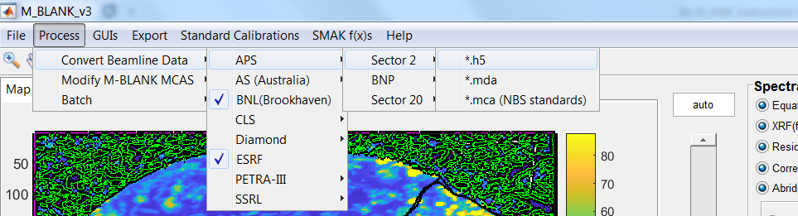
      - Select PROCESSES CONVERT BEAMLINE DATA, then select the SYNCHROTRON, SECTOR/BEAMLINE, and DATA FORMAT.
      - Follow the prompts by M-BLANK and then wait for the process to complete.
      - The progress should print out to the Read Out Log (see 3.1.9(a))

Combining Multiple Scans
At times it is advantageous to scan individual regions of an overall sample and stitch them together after the fact to avoid wasting time on image regions that contain no sample.
To stitch individual scans together:
- Convert the desired beamline data to *.mblank format (4.1 - Converting Beamline Data to *.mblank format).
- Select from the top menu: PROCESS MODIFY M-BLANK MCAS COMBINE MULTIPLE IMAGES INTO ONE
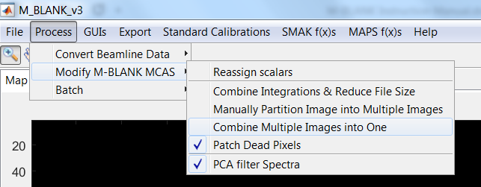
- Then select the data files you want to stitch
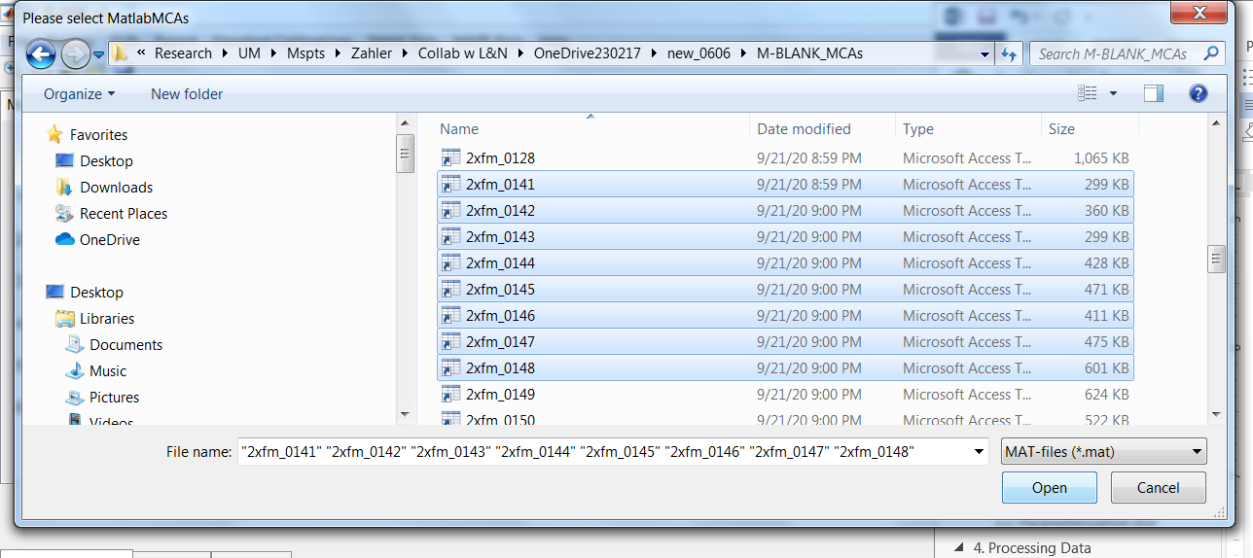
- You can select as many groups of files as you want. When you are finished selecting file groups press cancel to proceed naming and processing the files you selected.
- Then name the files for each of the groups you selected in steps 3 & 4
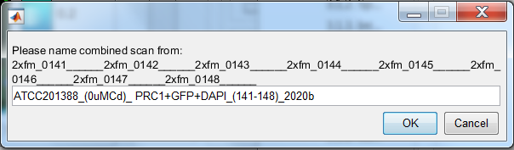
- M-BLANK will proceed to stitch the selected file groups into single files. The progress is printed to the Read out Display (see: 3.1.9 - Readout and Specifications)

Loading Raw Data in M-BLANK
Select from the top menu FILE LOAD MCA.
Spectra data require fitting parameters to be loaded in order to process. If fitting parameters are not loaded, M-BLANK will not proceed.

Creating Fitting Parameters
Fitting parameters (e.g., detector bin-to-energy calibration, detector response function, emission peak shapes, Compton (inelastic) scatter profile, Raleigh (elastic) scatter profile, etc.) can be derived from both samples and standards used for mass calibration. Because sample scans can be partitioned into ‘sample’ and ‘blank’ pixels, M-BLANK can use the difference spectrum from the mean of both regions for parameterization. Blank correction of the sample spectra, removes more than just a baseline XRF continuum because the blank contains structure and non-sample peak information. One of the advantages of correcting by a blank (rather than a baseline) is that the removal of this structure yields better precision and accuracy for fitting parameters as it changes, subtly, the apparent centroids of some of the fluorescence emissions.
Refer to 3.2 - Parameterization GUI for a graphical explanation of the user interface.

Launch the Parameterization GUI:
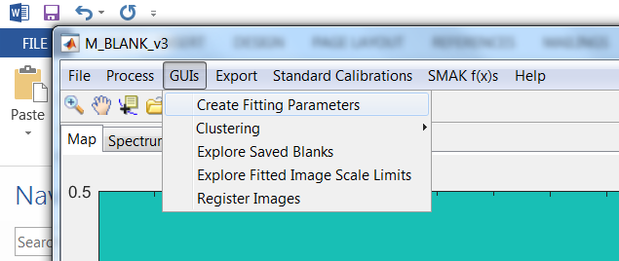
- Select GUIs CREATE FITTING PARAMETERS.
- The parameterization GUI will launch.

Creating fitting parameters
The user can create a new set of parameters from scratch or can load a previous set of parameters from a previous data set as a seed for a new set parameters.

Using previous parameters
- To use a previous parameter set as the seed for developing a new set of parameters, select from the top menu FILE OPEN SAVED SESSION.
- Then navigate to the folder of the fitting parameters session (this should be in the \M-BLANK\ParameterFittingOutput\ folder of the parent directory from which the parameters are to be used).
- The user will then need to reset the Parent Directory to the current directory that the user is working from. Do this pressing the “Get Parent Directory” Button (see: 3.2.n).
- Proceed to (4.3.2.2 Loading data for parameterization)

Loading data for parameterization
- Select FILE LOAD and then select the files you want to use to create a fitting parameter set
  - This should open to the “data” directory inside [PARENT DIRECTORY]/M-BLANK/.
  - If not, the files to be selected here are the in the user designated folder for the M-BLANK MCA format; in some cases, this folder is automatically generated in the PARENT DIRECORY.
- Once the scans are selected, M-BLANK will ask the following:
  - Whether or not there are background pixels
  - What value to normalize the data by (I0, I1, and Normalization by 1; these are set during file creation / format conversion).
- If you answered (NO) for (2.a) go to step (4.3.2.3).
- If you answered (YES) for (2.a), then M-BLANK will ask the user to identify energy regions using a rectangle to designate the left and right boundaries of the per-pixel spectra to be integrated. The user can select multiple. If multiple are selected, M-BLANK will display the integrated counts indexed into the corresponding x-, y-coordinates of the scan and ask which selected region the user would like to use for partitioning the scan into sample and non-sample pixels.
- Once the energy region is selected for partitioning into non-sample and sample pixels, partitioning can be done (1) automatically, or the user can manually partition the pixels by assigning an (2) image ROI or (3) threshold intensity from the 1D plot (referred to as MANUAL COLUMN VECTOR).
- If the user selects M-BLANK to automatically partition the pixels, refer to 4.8 (Identification and Refinement of ‘blank’ pixels).
- If user is using previous parameters as a seed (see: 4.3.2.1) , then proceed to 4.3.2.4 - Optimizing Parameters.
- Otherwise, user needs to proceed to 4.3.2.3 - Initializing New Parameters.

Initializing New Parameters
- This is done after data has been loaded (4.3.2.2 Loading data for parameterization).
- Click the Initialize Button (3.2.y)
- Initial Energy Calibration: M-BLANK calculates an initial energy calibration by having the user identify the elastic peak and assign the energy in units of keV. The user can also assign additional peaks and the associated energy in keV.
- Fitting Bounds: M-BLANK then designated the spectral region for fitting by having the user designate the left and right limits of the spectra to focus on for nonlinear optimization of fitting parameters.
- Compton and Elastic fitting constraints: M-BLANK has the user assign the lower and upper bounds (or constraints) for the Compton and elastic centroids.
- K, L, M, Pile-up/Sum-Peaks: M-BLANK then has the user assign the expected elemental emissions.
- Detector Response Function / Detector Energy Resolution: M-BLANK has the user assign the peaks of specific emissions. Each emission is fitted to the best fit Gaussian and the σ and energy are used to derive the detector response function according the “Fano” Equation (REFERENCE). See figure below.
- Select any of the text boxes and press ENTER to update the GUI with the initial parameters.

Optimizing Parameters
THIS NEEDS TO BE COMPLETED

Loading Fitting Parameters into M-BLANK
There are two ways the user can load fitting parameters:
- From the top menu in M-BLANK select FILE LOAD FITTING PARAM’S
- RIGHT-CLICK on the Parameters text box (see: 3.1.1.f) and select LOAD FITTING PARAMETERS.

Mass Calibration
M-BLANK comes preloaded with popular standard reference materials (e.g., NBS1832, NBS1833, and the AXO standard). However, different experiments may use different standards and as time passes new standard materials will arise. As such, it is necessary to be able to create custom standard reference files to fit the needs of the end users.

Creating a Standard Reference File (*.sref)
- Select from the top menu STANDARD CALIBRATIONS CALIBRATION CREATE STANDARD TEXT FILE.
- Type in the atomic symbols, areal density (µg cm⁻²) and thickness (cm).
- Select SAVE from the top menu FILE to save the *.sref file.
- The *.sref files are saved to [PARENT DIRECTORY]\M-BLANK\Reference_Standards.
Example:
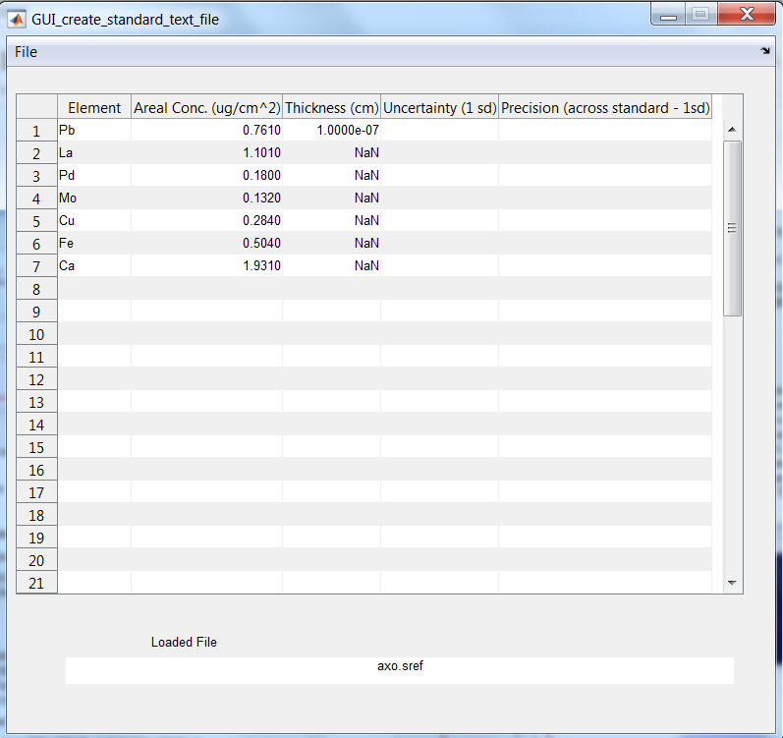

Creating/Calculating a Mass Calibration
- Make sure fitting parameters are loaded (see 4.3.3 - Loading Fitting Parameters into M-BLANK).
- Load Standard Data (see: 4.2 - Loading Raw Data in M-BLANK).
- Navigate to the standard data file that was converted to the M-BLANK (e.g., *.mblank) format (see: 4.1 - Converting Beamline Data to *.mblank format).
- Select the background function (see: j a-j), normalization ion chamber (see: 0g), and elemental emissions (see: 3.1.1h).
- Once the data has been properly fitted, select from the top menu STANDARD CALIBRATIONS CALIBRATION CREATE STANDARD CALIBRATION.
- Select the *.sref file (either preloaded or user defined here 4.4.1 - Creating a Standard Reference File (*.sref)).
- M-BLANK will calculate the mass calibration curves and then ask the user to give the mass calibration curve a name. See example below:
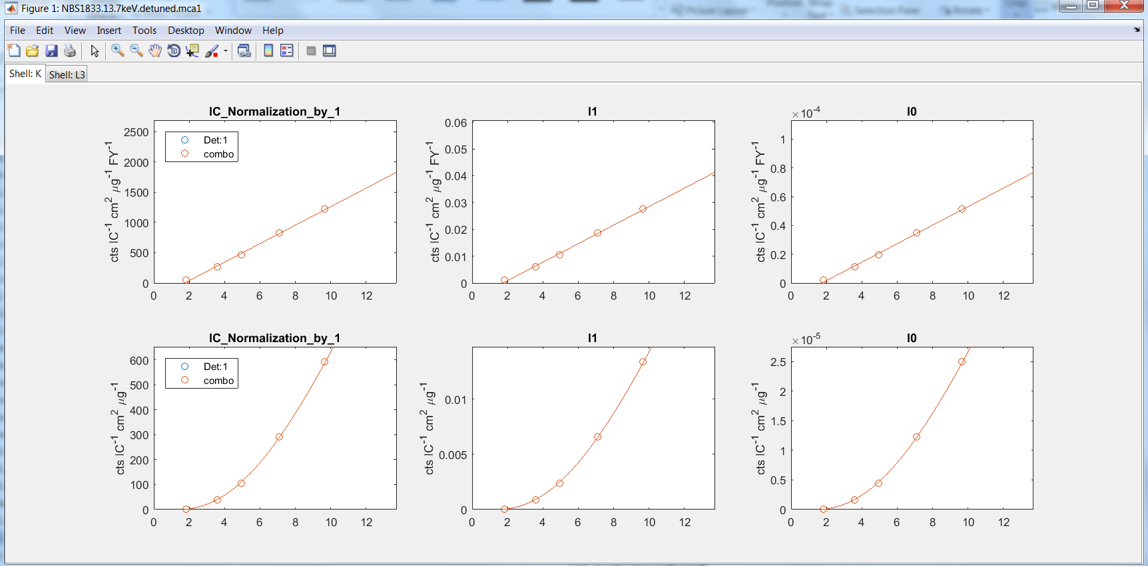
- The mass calibration file is saved to [PARENT DIRECTORY]\M-BLANK\Standard_Calibrations.

Combining Multiple Mass Calibrations into a single calibration
- Sometimes multiple standards are run to avoid overlapping emission lines or greater sensitivity across a dynamic range.
- To combine multiple mass calibrations into a single mass calibration select from the top menu: STANDARD CALIBRATIONS CALIBRATION COMBINE MULTIPLE STANDARD INFORMATION INTO NEW CALIBRATION.
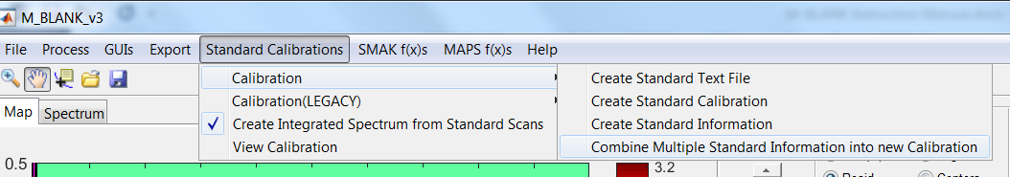

Loading Mass Calibration
There are two ways the user can load a mass calibration:
- From the top menu in M-BLANK select FILE LOAD STANDARD CALIBRATION
- RIGHT-CLICK on the Mass Calibration text box (see: 3.1.1.g) and select LOAD MASS CALIBRATION.

Fitting Data
- Make sure fitting parameters are loaded (see 4.3.3 - Loading Fitting Parameters into M-BLANK).
- If a mass calibration is available, load the mass calibration (see: 4.4.3 - Loading Mass Calibration).
- Load Sample Data (see: 4.2 - Loading Raw Data in M-BLANK).
- Select the background function (see: j a-j), normalization ion chamber (see: 0g), and elemental emissions (see: 3.1.1h).
- Partition the data into sample and non-sample as necessary (see: 4.8 - Identification and Refinement of ‘blank’ pixels).
- Save the fitted data by selecting the disk icon at the top menu.

Exporting Fitted Data

Fit Statistics:
M-BLANK can export fitted statistics to a comma separated ASCII file. This file contains the information for the user designated image regions of interest (ROIs). All ROIs are blank/background corrected.
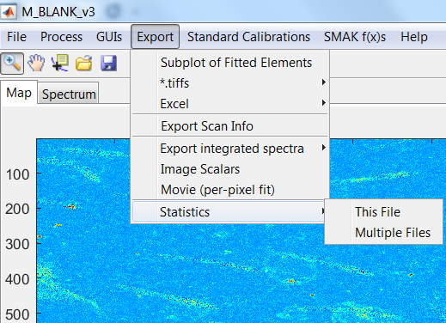
- To export the fitted ROI statistics from the current loaded dataset select from the top menu EXPORT STATISTICS THIS FILE.
- To export the fitted ROI statistics from multiple datasets select from the top menu EXPORT STATISTICS MULTIPLE FILES.

Fitted Images:
M-BLANK can export individual tiffs ( CROSSREF ) or file image montages ( CROSSREF ) and global image color scales for each element can be easily identified and used to constrain elemental maps across an entire dataset ( CROSSREF ) to better compare data.

Compatible Formats

SMAK
SMAK stands for Sam’s Microprobe Analysis toolkit [REFERENCE]. It was written by Dr. Sam Webb, PhD, from SSRL. Early in its development, M-BLANK was made compatible with SMAK and due to the ease of use (at that time) of the SMAK format, that format became embedded in many of the legacy operations of M-BLANK. This dependency on SMAK will be phased out until it is completely removed in future versions. For the time being, any functionality embedded in M-BLANK with dependencies on this format will be explicitly stated.
M-BLANK is capable of exporting both SMAK hdf5 and ASCII formats. Most legacy dependencies in M-BLANK require the hdf5 format.
To export SMAK format outputs select from the top menu SMAK f(x)s EXPORT SMAK COMPATIBLE OUTPUT and then select one of the four options displayed in the image below.
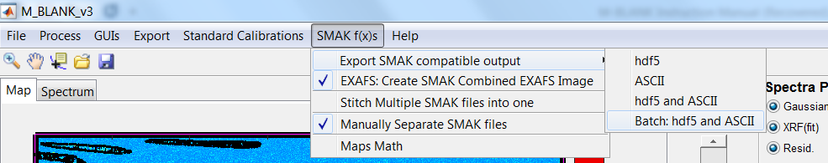
- hdf5 only exports the SMAK hdf5 format
- ASCII only exports the SMAK ascii format
- hdf5 and ASCII exports both formats
- Batch: hdf5 and ASCII batch exports both formats for multiple fitted datasets based on user selection.

Batch Processing
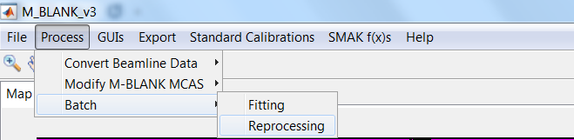

Batch Fitting Data
NEEDS TO BE INSERTED

Batch Reprocessing (Refitting Data)
- Select from the top menu PROCESSES BATCH REPROCESSING
- This opens a selection figure for different operations (explained graphically below).
- Select your desired options.
- Press ACCEPT (u).
- M-BLANK then goes through and reprocess all the selected data.
- Chill and let M-BLANK do its thing.
  - Combines the current selected emissions of the loaded file with the existing selected emissions in the files to be reprocessed.
  - User designates specific emissions to add the existing selected emissions in the files to be reprocessed.
  - User designates specific emissions to be removed from the existing selected emissions in the files to be reprocessed.
  - Changes the displayed element in the fitted file to the one that is currently displayed.
  - Applies the current selected normalization ion chamber to all the fitted files to be reprocessed.
  - Applies the current image scale (color bar scale) to the loaded files being reprocessed.
  - Applies the current loaded fitting parameters to all files being reprocessed.
  - Applies the current loaded mass calibration to all files being reprocessed.
  - Allows the borders to be cropped in all images being reprocessed.
  - Applies the current selected abridging settings to all reprocessed data.
  - Applies the current selected Gaussian Filter settings.
  - Exports the new fitted data to excel
  - If (l) is selected, this causes the fitted data resulting from all ion chamber normalization to be exported.
  - Applies the currently selected background function settings to al data being reprocessed.
  - Load a blank for the reprocessed data files.
  - Causes the blank to be calculated from the selected images themselves.
  - Applies the currently selected “Solve for Scatter” setting to all reprocessed files.
  - Applies the current energy range (window) to the reprocessed data.
  - Apply the currently selected USIC/DSIC.
  - Apply the current Edge Jump Forgiveness Setting
  - Accept the settings and reprocess data

Identification and Refinement of ‘blank’ pixels

Automatic Partitioning
For images containing both ‘sample’ and ‘blank’ pixels (e.g., any type of cell sparsely plated on a Si₃N₄ wafer), ‘blank’ pixels can be automatically partitioned in an iterative process using user-designated emission lines (or ROIs centered thereon) (Crawford, 2015, Crawford et al., 2016, Crawford & Penner-Hahn, 2018, Crawford et al., 2018). Initially, all pixels with intensities greater than a user-set threshold (typically, 0.1-0.2 the maximum emission or ROI signal) become defined as ‘non-blank’. Each iteration then calculates the mean, x̄, and standard deviation, σ, of the remaining ‘blank’ pixels. All pixels with intensities greater than x̄ + mσ, where m is a user-defined multiple of σ (typically, 2), are redefined as ‘sample’. This process repeats until the populations become self-consistent. See figure below:

Automatic Cropping/Rejection:
The population of ‘blank’ pixels can be further refined for calculating the blank spectrum by identifying and rejecting ‘abnormal’ pixels, e.g., pixels that contain contaminants such as dust. Similar to identifying ‘blank’ pixels above, the histograms of all the fitted elements from all ‘blank’ pixels are fitted to a normal distribution yielding a fitted standard deviation, σ, and population mean, x̄. All pixels with any elemental intensity I such that |I - x̄| > mσ, where m is a user defined multiple of σ (typically, 4), is rejected from the population and the process repeated until the population of identified pixels is self-consistent. See figure below graphically depicting a 3σ application.

Data diagnosing

Elemental Signal-to-Noise
Signal to noise can be evaluated by comparing the mean of the background to the … NEEDS TO BE FINISHED

Limit of sensitivity evaluation

